How to Download the Dashboard Data

Download as Data
- In order to make the data and crosstab download features available, you must click somewhere in the display of data. The easiest way to do this is to click a College name to show the blue focus box, then click it again to unfocus from that selection.
- Set any filters to create a specific view of the data or leave them set to “All” for all the data to be available.
- On the toolbar at the top of the page, click the download button
- The download options window should open
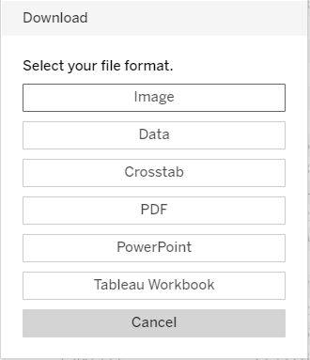
- Select Data
- A window with the data will open. You can select the Summary or the Full data tab at the top of this window.
- Next click the “Download all rows as a text file” hyperlink under the tabs
- This should output a CSV file in the browser.

Download as a Crosstab
- You must click somewhere inside the displayed data.
- On the toolbar at the top of the page, click the download button
- The download options window should open
- Select Crosstab

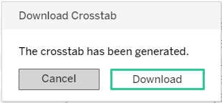
- A new pop-up informing you the crosstab has been generated will appear. Click download.
- This should output a CSV file in the browser.

