How to Set Up a Default View

- Apply all filters to create the view
- Click View on the toolbar
- In the pop-up window, give the new view a name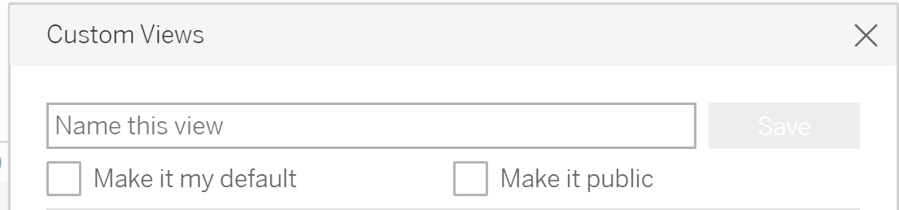
- Next, check the “Make it my Default” box

